 Traducido del inglés al español - www.onlinedoctranslator.com

This document summarizes the UNEP Finance Initiative's (UNEP FI) assessment of the bank's progress to date and the results of the feedback and review meeting. A letter to the Bank's Executive Director supplements this report. The assessment ratings are based on UNEP FI's review of the bank's reported progress in the practices and processes that a responsible bank is expected to undertake, based on the Principles' framework documents. They reflect judgments and market practices that continue to evolve. In preparing this assessment, UNEP FI relies on the bank's public environmental, social and governance reporting (including its underlying data and methodologies, and related limitations and dependencies), and does not assume any responsibility for, approve or endorse the information provided by the bank. This assessment should be used solely as a guide to the bank's progress in implementing the Principles. It is confidential and should not be disclosed to third parties.

United Nations Principles for Responsible Banking and Net Zero Banking Alliance
Individual progress report
June 30, 2025

Banco de la Producción S.A. Produbanco

Glossary
The evaluation and priority ratings have been assigned as follows, considering the Framework Documents of the Principles for Responsible Banking, the commitment to the Net Zero Banking Alliance (NZBA), and the guidelines and orientation of the NZBA documents::

Progress Evaluation
Yes | Complies with the mandatory elements and/or expectations of the Principles or NZBA Guidelines at the time of evaluation.
In progress | • Partially complies with the mandatory elements and/or expectations of the Principles or NZBA Guidelines and/or the bank confirmed that progress is being made.
No | Does not comply with the mandatory elements and/or expectations of the Principles or NZBA Guidelines.

Prioridad
High | Recommendations related to mandatory elements and/or expected milestones of the Principles or NZBA Guidelines that must be met for the next annual reporting cycle, within 12 months or the next NZBA target-setting milestone.
Medium | Recommendations related to mandatory elements and/or expected milestones of the Principles or NZBA Guidelines that are not necessarily required for the next annual reporting cycle, within 12 months or the next NZBA target-setting milestone..
Leading Practice | Recomendaciones basadas en prácticas de liderazgo y/o aspiracionales.
- | No recommendation.

Background Information
General Description
Banco de la Producción S.A. Produbanco (“the bank”) signed the Principles for Responsible Banking (the Principles) in June 2019. The ambition to act as a leading responsible bank aligned with each of the six PRB principles is guided by the PRB Implementation Journey and the Responsible Banking Blueprint.
Through these Principles, banks take action to align their core strategy, decision-making processes, lending, and investments with the United Nations Sustainable Development Goals (SDGs), agreements such as the Paris Climate Agreement, and other international and local frameworks. Signatory banks commit to incorporating the six principles across all business areas, at strategic, portfolio, and transactional levels.
Banks are expected to lay the foundations for continuously embedding these Principles into their operations by undertaking initial steps: understanding their portfolio’s impact and establishing at least two ambitious and measurable targets that address the most significant impact areas of the bank. These steps, including the establishment of both targets, are expected to be completed within four years following the signing of the Principles.}
To work towards being responsible banks, institutions must strengthen their governance structures, align their business strategies, and actively engage with clients, stakeholders, and employees according to the six principles. Banks are expected to have action or transition plans to achieve the set targets and strive for continuous progress throughout the implementation of the PRB. The bank will annually report on its progress in implementing the Principles.
Additionally, the bank signed the Net Zero Banking Alliance (NZBA) Commitment on [DATE]. NZBA signatories adhere to the Guidelines for Climate Target Setting for Banks, which includes independently setting their first round of targets within 18 months after signing the Commitment and, within the subsequent 18 months, establishing targets for all or the majority of carbon-intensive sectors. The target setting will be underpinned, within 12 months after publication, by the disclosure of at least a high-level transition plan outlining planned actions and milestones for achieving these targets.

Principle 1:

Alignment
We will align our business strategy to be consistent with and contribute to the needs of individuals and the goals of society, as expressed in the Sustainable Development Goals, the Paris Climate Agreement, and relevant national and regional frameworks.

Evaluación del progreso | Prioridad
Yes | Medio
Produbanco is a financial institution that is part of the regional group Promerica Financial Corporation (PFC), with operations in nine countries across Central and South America. Its objective is to carry out all types of operations and services permitted by the Organic Monetary and Financial Code aimed at fostering the development of the country’s productive activities, implementing a solid strategy to contribute to the Paris Climate Agreement (GHG reduction) and the Sustainable Development Goals (SDGs), as well as other national and international frameworks such as the Principles for Responsible Banking, the Net Zero Banking Alliance (NZBA), and Sistema B.
In this regard, and in response to our customers' needs, we are in the process of developing a new sustainability strategy that will contribute to achieving our purpose of generating value with a sustainable approach to transcend people's lives. This strategy will be unveiled next year.
During 2024, the commitment to sustainable financing was maintained. A total of 210 million dollars was managed, originating from two financial institutions (one local and one international), allocated to credit operations aligned with the categories of the bank’s Sustainable Portfolio, distributed as follows:
- Women-led SMEs: $40.5 million
- Climate – Green Lines: $54 million
- SMEs: $63 million
- Biodiversity – Green Lines: $22.5 million
The total sustainable portfolio for 2024 amounted to $1.052 billion, allocated as follows:
- Women Retail: $498 million
- Green Lines: $353 million (including $66 million for the blue economy)
- Women-led SMEs: $80 million
- Development SMEs (formerly “vulnerable sectors”): $64 million
- Silver SMEs (older adults): $40 million
- Youth-led SMEs: $6 million
- SMEs in Health: $6 million
- SMEs in Education: $5 million

In 2023, the impact analysis covered both corporate/business and consumer banking segments.

Segment | Exposure | Participation
Consumer Banking | $2,202,020,729 | 43%
Investment Banking (SMEs + Corporate) | $2,831,016,087 | 55%
Others | $80,956,421 | 2%
Total | 5,113,993,237 | 100%

This means that 98% of Produbanco’s total portfolio was covered in the impact analysis.

Consumer Banking Analysis

Products | Participation
Current Accounts & Savings
Current accounts | 9.15%
Savings | 2.92%
Savings accounts | 42.55%
Certificate of deposits | 45.38%
Total | 100%
Credit
Credit Cards | 51.8%
Consumer Loans | 27.98%
Mortgages | 11.50%
Vehicle Loans | 8.29%
Education loan | 0.03%
Microcredit | 0.4%
Total | 100%

Impact Result

The results obtained for negative and positive impact related to credit are the following:
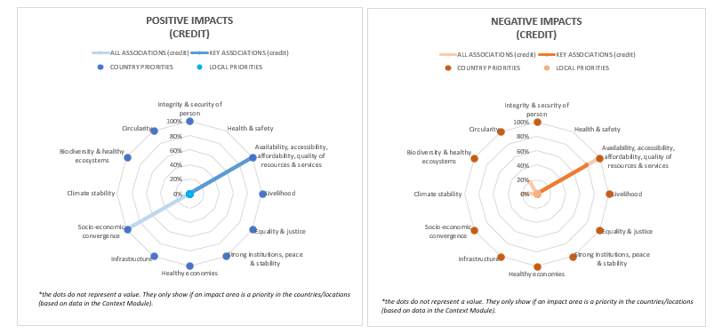

The results obtained for negative and positive impact related to savings are the following:
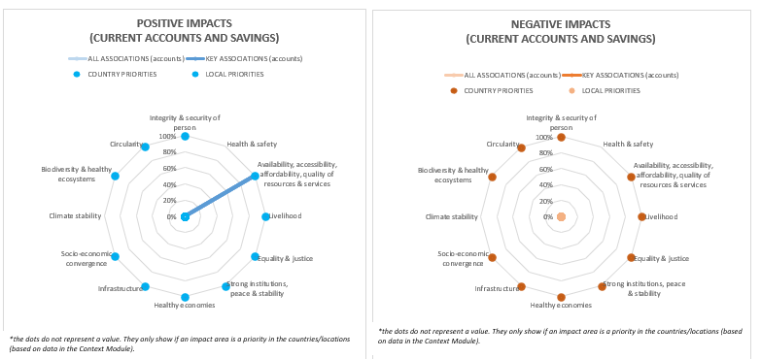

In addition, we include age and gender information, obtaining the following results:

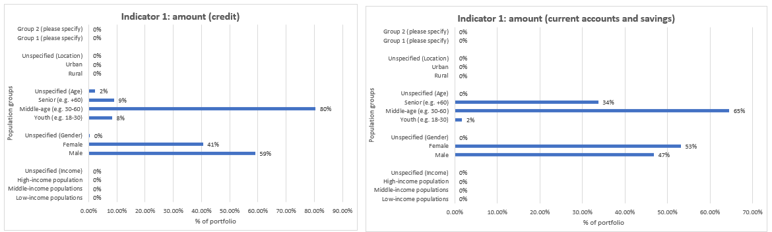

As a result, it can be observed that in credit we have a positive impact in “Availability, accessibility, affordability, quality of resources & services” and in “Socio Economic Convergence”. Moreover, Produbanco has given more credit to people between 30-60 years old and male.

In terms of current accounts and savings, we have a positive impact in the same impact area as credit. Opposite to credit, Produbanco has more female clients with these types of products.

In relation to the results for investment banking, which is associated to corporate/business banking, the data used for Corporate and SMEs for 2023 impact analysis is the following:

Activity | Corporate Participation | SMEs Participation | Total Participation
01 Crop and animal production, hunting and related service activities | 0.78% | 1.14% | 1.92%
0119 Growing of other non-perennial crops | 0.48% | 0.86% | 1.34%
0122 Growing of tropical and subtropical fruits | 0.11% | 0.92% | 1.03%
0126 Growing of oleaginous fruits | 0.71% | 0.14% | 0.85%
02 Forestry and logging | 0.45% | 0.09% | 0.54%
031 Fishing | 0.33% | 0.04% | 0.37%
032 Aquaculture | 0.59% | 3.23% | 3.82%
B Mining and quarrying | 0.16% | 0.12% | 0.28%
06 Extraction of crude petroleum and natural gas | 0.77% | 0.00% | 0.77%
C Manufacturing | 5.28% | 1.62% | 6.90%
10 Manufacture of food products | 7.73% | 3.10% | 10.83%
11 Manufacture of beverages | 0.00% | 0.16% | 0.16%
12 Manufacture of tobacco products | 0.00% | 0.00% | 0.00%
13 Manufacture of textiles | 0.04% | 0.67% | 0.71%
14 Manufacture of wearing apparel | 0.19% | 0.36% | 0.55%
16 Manufacture of wood and of products of wood and cork, except furniture; manufacture of articles of straw and plaiting materials | 0.52% | 0.03% | 0.55%
170 Manufacture of paper and paper products | 0.01% | 0.72% | 0.73%
20 Manufacture of chemicals and chemical products | 1.13% | 0.72% | 1.85%
22 Manufacture of rubber and plastics products | 0.24% | 0.58% | 0.81%
29 Manufacture of motor vehicles, trailers and semi-trailers | 0.17% | 0.04% | 0.21%
TOTAL C NOT CONSIDERED
35 Electricity, gas, steam and air conditioning supply | 2.96% | 0.40% | 3.36%
E Water supply; sewerage, waste management and remediation activities | 0.26% | 0.05% | 0.30%
F Construction | 0.02% | 0.49% | 0.51%
4100 Construction of buildings | 2.29% | 1.09% | 3.38%
45 Wholesale and retail trade and repair of motor vehicles and motorcycles | 7.89% | 1.52% | 9.41%
46 Wholesale trade, except of motor vehicles and motorcycles | 2.96% | 7.05% | 10.01%
47 Retail trade, except of motor vehicles and motorcycles | 6.83% | 2.93% | 9.76%
H Transportation and storage | 0.94% | 1.19% | 2.13%
55 Accommodation | 0.70% | 0.16% | 0.86%
56 Food and beverage service activities | 1.78% | 0.51% | 2.29%
J Information and communication | 0.24% | 0.94% | 1.18%
K Financial and insurance activities | 2.60% | 0.19% | 2.78%
6810 Real estate activities with own or leased property | 6.82% | 1.71% | 8.53%
682 Real estate activities on a fee or contract basis | 3.10% | 1.01% | 4.11%
M Professional, scientific and technical activities | 0.60% | 0.84% | 1.44%
N Administrative and support service activities | 1.62% | 1.54% | 3.16%
84 Public administration and defence; compulsory social security | 0.00% | 0.00% | 0.00%
85 Education | 0.01% | 1.07% | 1.08%
Q Human health and social work activities | 0.16% | 1.09% | 1.24%
R Arts, entertainment and recreation | 0.00% | 0.05% | 0.05%
S Other service activities | 0.00% | 0.17% | 0.18%
T Activities of households as employers; undifferentiated goods- and services-producing activities of households for own use | 0.00% | 0.00% | 0.00%
Total | 61.48% | 38.52% | 100.00%

Therefore, we have covered the whole investment banking, where the participation of SMEs is a 39%, while the corporate participation is a 61%.

We are also pleased to report that, in 2024, Produbanco prepared the “Progress Report on the Net Zero Banking Alliance,” which was submitted to UNEP FI in November for review. The report includes:
- The progress made since Produbanco became a signatory of the NZBA (2021)
- The methodology used to define our decarbonization targets for 2030 and 2050, considering various scenarios
- The gradual phase-out of the coal sector:
- For Scope 3 emissions, only those related to oil extraction are included. Due to the limited quality and availability of data, Scope 3 emissions from other sectors will not be published or considered in 2024. Starting in 2026, the inclusion of Scope 3 emissions from all priority sectors will be assessed, depending on data availability.
- The report also details the justifications for not having decarbonization targets in the following carbon-intensive sectors:

CARBON-INTENSIVE SECTORS | JUSTIFICATION | STATUS
STEEL | Data is currently insufficient to quantify emissions in this sector. We have made progress in improving data quality by working directly with clients in the sector, but for now it is not possible to set a decarbonization target. | In progress. A medium-term target is expected to be established.
CEMENT | No target has been set for this sector, in line with the 5% materiality threshold adopted by the bank. This sector represents 0.53% of the bank’s total financed emissions and 0.52% of the productive portfolio. | Not material, as it represents less than 5% of total financed emissions and financial exposure.
Aluminum | No target has been set for this sector, in line with the 5% materiality threshold adopted by the bank. This sector represents 1.47% of the bank’s total financed emissions and 2.51% of the productive portfolio. | Not material, as it represents less than 5% of total financed emissions and financial exposure.
Real Estate | Data is currently insufficient to quantify emissions in this sector. We have made progress in improving data quality, but for now it is not possible to set a decarbonization target. | In progress. A medium-term target is expected to be established.
Transport | Data is currently insufficient to quantify emissions in this sector. We have made progress in improving data quality, but for now it is not possible to set a decarbonization target. | In progress. A medium-term target is expected to be established.

The Progress Report on the Net Zero Banking Alliance is publicly available at the following link: https://www.produbanco.com.ec/media/poniynx2/objetivos-nzbaoct2024.pdf

Principle 2:

Impact and Target Setting
We will continuously increase our positive impact, while reducing negative impacts and managing risks to people and the environment derived from our activities, products, and services. To achieve this, we will establish and publish targets where we can achieve the greatest significant impact.
Impact Analysis
Progress Assessment |  | Priority
Yes |  | Medium
Scope and Impact Identification | Produbanco has established two targets related to the impact areas of Climate and Resource Efficiency (Circularity). These targets are primarily based on the Sustainable Development Goals:  - SDG 7: Affordable and Clean Energy  - SDG 12: Responsible Consumption and Production  - SDG 13: Climate Action  Additionally, other frameworks considered include:  - NZBA (Net Zero Banking Alliance)  - SBTi (Science Based Targets initiative)  - IEA (International Energy Agency)  - IPCC (Intergovernmental Panel on Climate Change)  Based on the sectors prioritized for both Climate and Resource Efficiency impact areas, the most aligned action lines from Ecuador’s NDCs (Nationally Determined Contributions) are:  Agriculture:  - Promote research and develop information systems to strengthen climate adaptation in the livestock sector  - Foster sustainable livestock development  Industrial Processes:  - Support the generation, exchange, and dissemination of information to drive mitigation actions in the industrial processes sector.
Monthly performance and evaluation | For Produbanco, it has been essential to define SMART indicators aligned with global initiatives such as the Paris Agreement and the SDGs. Monitoring progress and meeting the established targets is part of our ongoing commitment.  Produbanco aims to increase its resource efficiency portfolio by 17% by 2050 in the agriculture, manufacturing, and construction sectors. The following intermediate targets have been defined:  - 4% by 2030  - 7% by 2040  To achieve these goals, we will increase the number of clients for whom we have resource efficiency data from 4% to 10% by 2030, focusing on the agriculture, manufacturing, and construction sectors.

Target 1 – Climate
Progress Assessment |  |  | Priority
Goal Setting | Yes |  | Medium
The intermediate decarbonization targets established in 2022 are maintained. These targets apply to five sectors and are based on carbon intensity targets (i.e., GHG emissions per deflated revenue):
- 24% Agriculture, livestock, hunting, and others
- 24% Fishing and aquaculture
- 36% Electricity supply
- 18% Oil extraction
- 24% Food product manufacturing

To set the decarbonization targets for these five sectors, the following were used as reference: the reduction curve, Ecuador’s conditional NPC scenarios, IPCC C2, and IEA, in the following manner:
Table 5: Emission reduction targets by prioritized sector by 2050

ISIC | Subsector | Monetary Intensity Ratio (tCO2eq/1MM USD) | % Expected Reduction |  |  |  | Monetary Intensity Ratio (tCO2eq/1MM USD)
 |  | 2021 | 2030 | 2040 | 2050 | 2030 |  | 2040 | 2050
A01 | Agriculture, Livestock, Hunting & Others. | 581 | -24% | -68% | -100% | 442 |  | 185 | 0
A03 | Fishing and Aquaculture. | 325 | -24% | -68% | -100% | 248 |  | 104 | 0
B06 | Crude Petroleum and Natural Gas Extraction | 963 | -18% | -57% | -91% | 794 |  | 418 | 87
C10 | Food Product Manufacturing | 17 | -24% | -68% | -100% | 13 |  | 6 | 0
D35 | Electricity Supply | 353 | -36% | -84% | -103% | 225 |  | 56 | -10
* The monetary intensity ratio considers GHG emissions relative to real sales, multiplied by a deflator to eliminate the effect of inflation.

Target Implementation and Action Plan | In Progress |  |  |  | Medium
Transition Plan: Among the actions carried out to fulfill our commitment to the NZBA, we highlight the following:
- Development of a policy and taxonomy for Produbanco’s Green Lines, including the definition of methodologies for eligibility criteria and impact calculation. This process aligns with the green taxonomy developed by Asobanca for financial institutions in Ecuador.
- Surveys and client visits within the iron and steel sector to understand their current context and identify decarbonization progress.
- Integration of climate risk information into the SARAS georeferencing tool.
- Collection of client data through SARAS to improve data quality.
- Strengthening the capabilities of the commercial force.
- Launch of a project for the direct quantification of 50 carbon footprints of clients in the productive portfolio — including SMEs, business, and corporate segments — in partnership with the consultancy Global Factor. The project also includes the development of action plans for those clients.

In addition, attached is Produbanco's timeline, which shows the steps it has established to achieve Net Zero for its productive portfolio by 2050:

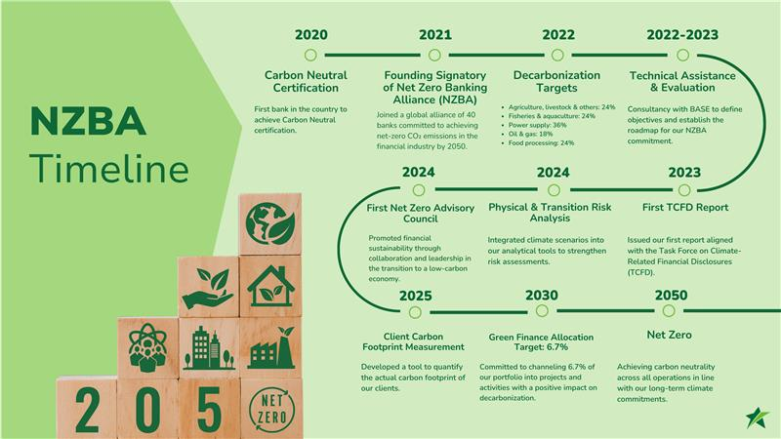

Monitoring and disclosure of objectives | In 2023, with the support of technical assistance from FinDev Canada, Produbanco applied the JIM PCAF tool to improve the estimation of financed emissions in its portfolio. This tool is based on the PCAF methodology, but unlike other alternatives, it incorporates GTAP-based datasets specifically tailored for Ecuador. In previous calculations, the emission factors used were based on regional or developing-country averages, which increased the uncertainty in emission quantification.  Below are the greenhouse gas (GHG) emissions of Produbanco’s productive portfolio from the sectors prioritized by NZBA and by Produbanco, corresponding to fiscal years 2021, 2022, and 2023.  To enhance our understanding of resource efficiency indicators, we will assess the feasibility of establishing a baseline for our portfolio by participating in relevant events and through mass information collection from our commercial portfolio.  Category 15: Investments  Total GHG Emissions 2021 2022 2023  Scope 1 (tCO2eq) 297.450,23 320.728,33 330.826,61  Scope 2 (tCO2eq) 83.410,45 90.229,03 95.743,12  Scope 3 (tCO2eq)* 52.03 151.02 1.617,26  Total Emissions (Scope 1 & 2) 380.860,67 410.957,37 426.569,73  Below are the advances in the five activities prioritized by Produbanco with respect to the decarbonization target set for 2030, as well as the bank’s stance on the coal sector..  It is important to note that progress toward decarbonization targets is not expected to be linear in the short term.  In 2024, in line with NZBA commitments, Produbanco remains in the process of defining physical intensity targets for the financed portfolio in the priority sectors, following the sectoral decarbonization approach methodology of the Science Based Targets initiative (SBTi).
Potential negative impacts and negativos negativos e interrelaciones | There are no negative impacts to report in this submission.
Target 2 – Resource Efficiency
Progress assessment |  |  |  | Priority
Target setting |  | Yes |  | Medium
To improve resource efficiency, we have decided to promote non-financial offerings. In 2024, we formalized energy efficiency and renewable energy program. The program encourages the acquisition of more efficient production equipment and renewable energy, aligned with the country's current regulations (Ministerial Agreement No.048). The service provided under this program includes "Green Talks", that is training on energy efficiency, and a feasibility report for those interested in receiving the benefits of the regulation. We have three partners that will offer this service to our clients.

Additionally, we continue with the sustainable construction program, sponsoring EDGE and Ecosustenta certifications together with the Ecuadorian Sustainable Building Council (which is part of the World Building Council). In 2024, we supported four construction projects, increasing the green lines portfolio by 40 million dollars. These projects achieved savings of over 20% in water, energy, and embedded materials.
Target implementation and action plan |  | In progress |  |  |  | Medium
In 2024, we had a consultancy to establish Green Lines policies and the construction of the internal Green Taxonomy, which led to the development of a tool to calculate green impacts. This tool helps track the impacts of clients and projects that contribute to the circular economy, translating this data into impacts related to Climate Change Mitigation, thereby improving the connection between prioritized sectors.

In 2025, we will work on the feasibility of establishing a baseline for impacts related to resource efficiency across the entire commercial portfolio.
Target monitoring and disclosure |  | Regarding the progress of the resource efficiency objective, in 2024 the portfolio decreased by 18% due to amortizations. On the other hand, the client engagement percentage increased from 4% to 7%. This means we obtained more information and client projects; however, the amount of tickets loans generated was low, and we could not cover the amortization.
Potential negative impacts and interlinkages |  | There are no negative impacts to report in this submission.

Principle 3:

Clients and Consumers
We will work responsibly with our customers and consumers to promote sustainable practices and enable economic activities that create shared prosperity for current and future generations.
Progress Assessment | Priority
Yes | Medium
The creation of strategic alliances helps achieve objectives by promoting positive environmental and social practices and strengthening the sustainable value chain. In 2024, we enhanced our non-financial offerings with the following actions:

- Training and Events: In 2024, we conducted 4 Green Talks on construction efficiency and sustainability, with over 250 attendees. We also organized a financial education event for new businesses, with 80 participants, and two sustainability training programs with B Corp, involving 19 SMEs and 10 corporate entities.

- Technical Assistance: We formalized the Technical Assistance program for SMEs. In 2023, with the support of Findev Canada, 20 Produbanco employees were certified in the "Growing Your Business" methodology by the UNDP. In 2024, two certified advisors provided technical assistance to our SME clients in the coastal and highland regions. That year, 51 clients received technical assistance, which has been reflected in their relationship with us, increasing deposits by 126% and credit portfolio by 76%.

- Energy Efficiency and Renewable Energy Program: In 2024, we formalized an energy efficiency and renewable energy program. The program encourages the acquisition of more efficient production equipment and renewable energy, aligned with the country's current regulations (Ministerial Agreement No.048). The service provided under this program includes "Green Talks," which is training on energy efficiency, and a feasibility report for those interested in receiving the benefits of the regulation. We have three partners that will offer this service to our clients.

- Sustainable Construction Program: We proactively provide support for obtaining EDGE and Ecosustenta certification (developed in collaboration with the Ecuadorian Sustainable Building Council, for non-residential construction). In 2024, we supported 4 projects, increasing the Green Lines portfolio by 40 million dollars. The projects achieved savings in water, energy, and materials exceeding 20%.

Produbanco manages a Sustainable Portfolio that encompasses various categories of social and environmental impact, reaching 19% of the total loan portfolio by the end of 2024. Produbanco also leads the market with over 30% market share in sustainable portfolios.

Credit Categories of the Sustainable Portfolio

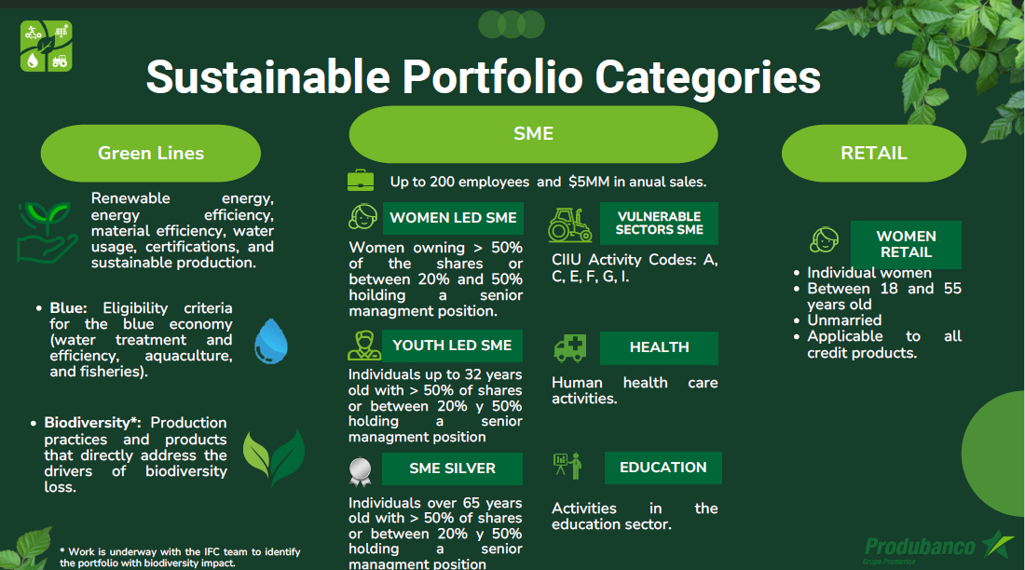

Our commitment is to support our clients in their transition toward more sustainable operations through guidance, training events, and strategic partnerships to foster the adoption of sustainable practices. Additionally, on the social impact side, we have the Protagonistas program, which seeks to promote gender equity both internally among employees and externally with clients.

We closed the year with $353 million in Green Lines portfolio. This achievement is particularly significant given that we disbursed over $358 million this year, representing an 80% increase compared to the previous year and marking substantial growth in disbursements across all banking segments

Produbanco supported nearly 10,000 SME clients through a portfolio of 4,172 loans, totaling USD 532 million by year-end. 36% of these loans were granted to companies located outside Quito and Guayaquil, reflecting Produbanco's commitment to the local economic development of regions where it operates. The loan portfolio was distributed among various economic sectors: trade (35%), manufacturing industries (15%), and agricultural activities (14%). Of the total disbursements made in 2023, 59% were allocated to working capital and 41% to Capex.

Produbanco is committed to generating social, environmental, and economic impact through its financing, aligning with funders offering thematic funds benefiting various stakeholders. In 2022, Produbanco issued the first Sustainable Bond in Ecuador, aimed at contributing to the country's sustainable development across multiple areas. This bond undergoes annual verification by an independent third party to certify the impacts generated by the financed portfolio. By the third year since issuance, the impacts achieved are as follows.

Regarding women-led SMEs, more than 100 companies benefited, including over 10 exporting companies, positively affecting around 2,000 jobs and 5,000 indirect beneficiaries.
For youth-led SMEs and SMEs in vulnerable sectors, more than 160 companies benefited, including over 16 exporting companies, positively impacting approximately 4,287 jobs and 9,000 indirect beneficiaries.

Concerning the environmental impact indicators generated by the Sustainable Bond, achievements include savings of 72,000 m³/year of water, avoidance of 45,000 tCO₂/year, certification of 333,000 tons/year of sustainable production, certification of 3,000 hectares of land, 143.6 MWh/year of energy savings, 13,000 gallons/year of diesel fuel avoided, and recycling of 9,000 tons/year the recycled of materials (sustainable bond).

Principle 4:

Stakeholders
We will proactively and responsibly consult, collaborate, and partner with relevant stakeholders to achieve society’s goals.
Progress Evaluation | Priority
Yes | Leading Practice
As part of the continuous improvement of our sustainable management model, we conducted a Double Materiality Assessment with the support of Valora Consulting. Through various listening and dialogue tools with different stakeholder groups, we obtained both financial and impact materiality insights.

Based on these findings, the most relevant topics were defined, considering their importance to stakeholders and their impact on institutional management.

No. | Topic | Category
2 | Financial product innovation | DOUBLE
3 | Customer satisfaction and experience | DOUBLE
6 | Climate strategy | DOUBLE
8 | Talent management and well-being | DOUBLE
11 | Business development | DOUBLE
14 | Financial education | DOUBLE
15 | Ethics and responsible communication | DOUBLE
17 | Digital security and information privacy | DOUBLE
1 | Sustainable finance | FINANCIAL
4 | Environmental and social risk management | FINANCIAL
18 | Corporate governance and business continuity | FINANCIAL
9 | Labor practices | IMPACT
10 | Financial inclusion and well-being | IMPACT
16 | Digital innovation | IMPACT
Source: Double Materiality Study 2025 – Sustainability and Social Responsibility Report

The objective of the double materiality assessment is to prioritize ESG issues through:

- Impact Materiality: Prioritization of the impacts that operations have on stakeholders.

- Financial Materiality: Prioritization of the risks and opportunities that these ESG issues may pose to financial performance.

Both materialities coexist to define material topics of impact, financial, and double materiality, allowing us to focus efforts on the definition of strategies that contribute to the application of good practices in sustainability and social responsibility within Produbanco and its subsidiaries.

Furthermore, Produbanco continues to be a member of the Board of Directors of the Ecuadorian Corporate Social Responsibility and Sustainability Corporation (CERES), a member of the Sustainability Committee of the Ecuadorian-American Chamber of Commerce (AMCHAM), and of the Board of Directors of the Association of Private Banks of Ecuador (ASOBANCA). It also serves as Chair of ASOBANCA’s Sustainable Finance Committee. Since 2024, Jorge Alvarado, Vice President of Legal, Compliance, and Corporate Affairs, has been appointed as a member of the UNEP FI Banking Board, representing South America on this prestigious board with a sustainable and responsible focus.

Principle 5:

Governance and Culture
We will implement our commitment to these Principles through effective governance and a culture of responsible banking.
Progress Assessment | Priority
Yes | Medium
Produbanco has a governance model that integrates climate change issues at the highest levels of decision-making. Our environmental approach is based on risk prevention, both inherent to the business—in terms of the activities carried out by clients with financing—as well as risks arising from institutional operations.

To strengthen our sustainability strategy and support our clients in the implementation of sustainable practices, two specialist sustainability advisor positions were created, whose functions are:
- Provide technical assistance to MSME clients through the Growing Your Business methodology.
- Conduct on-site visits with business officers to identify opportunities.
- Promote the growth of the sustainable portfolio.

Additionally, specific performance ratings and a variable compensation scheme were established, linked to meeting and exceeding budget targets.

A guide called Non-Financial Sustainability Offer was also designed as a reference manual so that commercial advisors can offer different benefits to clients.

Furthermore, throughout the year, members of the Board of Directors received the following training sessions:

Pillar | Topic | Date of Execution | Delivered by
1. Technology | Robotics and Artificial Intelligence | April 3 | Automation Anywhere Microsoft
2. Talent Management | The Skills Economy | May 3 | HR Business Agility Partner - Agility Changes Eduardo Lafeber
3. Compliance | Training on Prevention of Money Laundering & Financing of Terrorism Field of Study and Topic Compliance ALA/CFT/PACM | April 4May 9May 24 | CSMB Ana María H. de Alba
4. Finance | Sustainability Standards S1 and S2 | June 3 | KPMG
5. Risks | Frauds and Cybercrime | July 3 | Visa Luis Reza
6. Corporate Governance | Corporate Governance and Compliance Trends | August 30 | Fit & Proper Marcelo Zárate
7. Compliance | AML/CFT Training for Committees’ Directors (AML, AUD, RI) | September 3 | CSMB Ana María H. de Alba
8. Risks | Management of Non-Financial Risks: A complex but highly relevant challenge | September 10 | PWC Bismark RodríguezLeónidas ReyRaúl de García
9. Compliance | AML/CFT Training for Credit Committee Directors | October 17 | Infolat Alberto Lozano
10. Corporate Governance | Basel Trend | November 7 | Fit & Proper Marcelo Zárate

Note (1): The audience was divided into 3 groups that received the same content.

Additionally, we continue working and seeking new opportunities to strengthen our governance systems.

Principio 6:

Transparencia y rendición de cuentas
We will periodically review our individual and collective implementation of these Principles and will be transparent and accountable for our positive and negative impacts and our contribution to society's goals.
Progress Evaluation | Priority
Yes | Leading practice
Produbanco is committed to periodically reviewing its implementation of the Principles for Responsible Banking, as well as ensuring transparency through its reports regarding its management practices, the impact generated, and its contribution to the SDGs.

Produbanco’s sustainability reports are prepared annually following selected GRI Standards, through which we gather general, basic, and specific topics from the Financial Services Sector Supplement. We also incorporate progress on commitments related to the Principles for Responsible Banking, TCFD, SASB, IFRS S1 and S2, the Global Compact, among others.

The latest published report covers the period 2024 and is publicly available here: memoriasostenibilidad_2024.pdf
We have also published our third TCFD Report, which is available on our website as part of our financial report: tfcdingles.pdf

